PRELAB 4

Shobhit Chaudhry-20553474

Aakash Ravichandran-20554713

|  |  |  |  |  |
| --- | --- | --- | --- | --- |
| Circuit | Parameter | Prelab  (Calculation) | Prelab  (Simulation) | In-lab  (Measured) |
| Peak detector | Peak voltage Vp | 3V | 2.8596 V |  |
| Ripple voltage Vr | 63.829mV | 196.3 mV |  |
| Negative clamp | Max. output voltage | 0V | 0.042 V |  |
| Min. output voltage | -2V | -1.9586V |  |
| Voltage doubler | Steady-state peak output voltage |  | -4.74V |  |
| Diode limiter | Max. output voltage | 0.62 V | 0.517 V |  |
| Min. output voltage | -0.62V | -0.517 V |  |
| Half-wave rectifier | Max. output voltage |  | 1.4498 V |  |
| Min. output voltage |  | 161.97e-6 V |  |
| Precision rectifier circuit | Max. output voltage |  | -0.041V |  |
| Min. output voltage |  | 1.9637V |  |
| Diode I-V characteristics | Cut-in voltage |  | 0.454 V |  |

Datasheet attached at the end

Q 4.1

Peak detector:

Vr=Vp/fRC

Vr= 3/(100 x 10x 10^3 x 47x10^-6) Volts

Vr= 0.063829 V = 63.829 mV

Transient Analysis: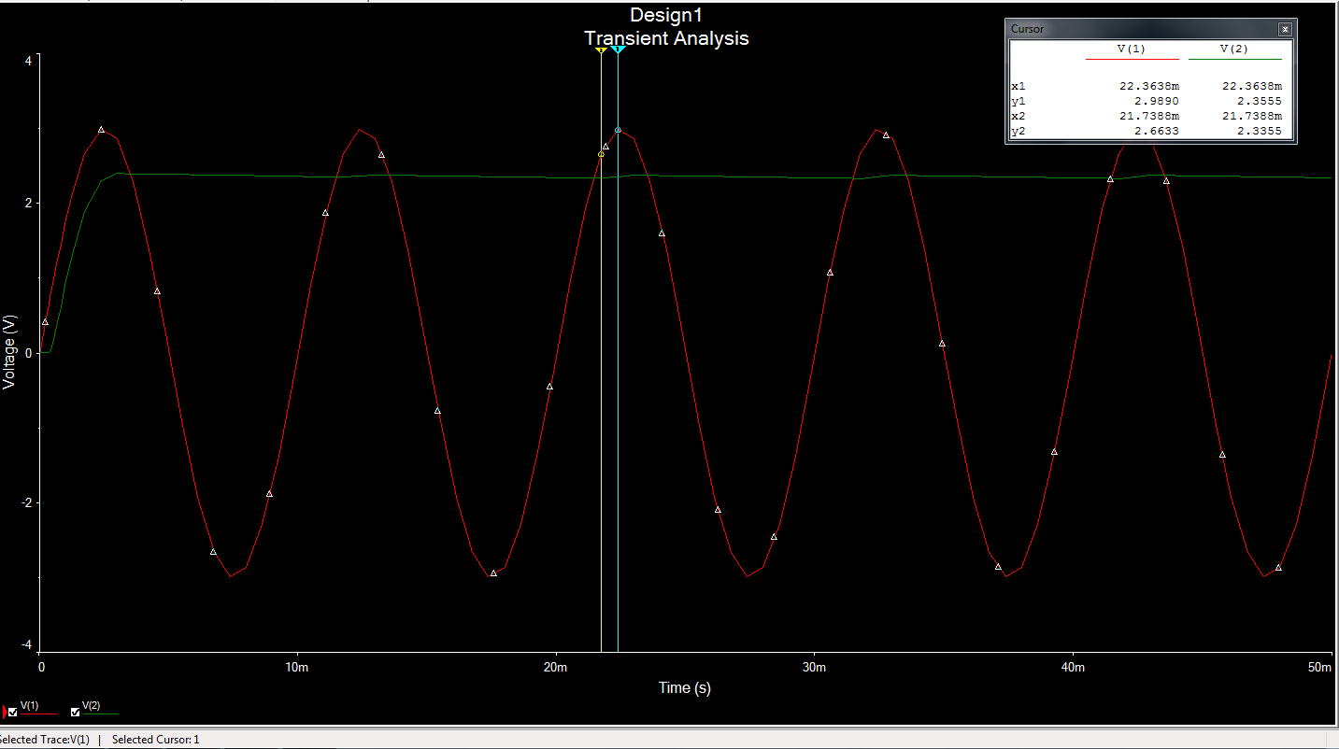

Zoomed in view for peak and ripple voltage: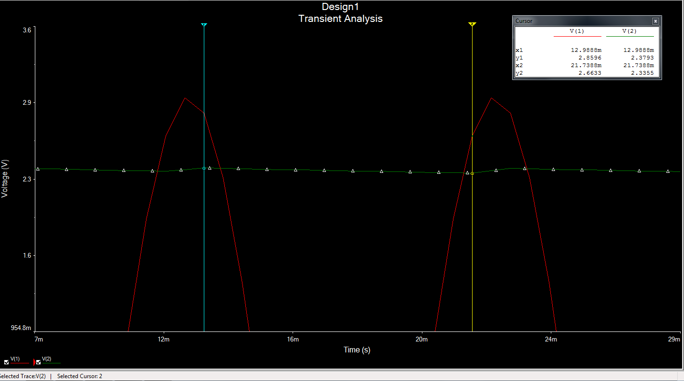

4.2 Negative Clamp:

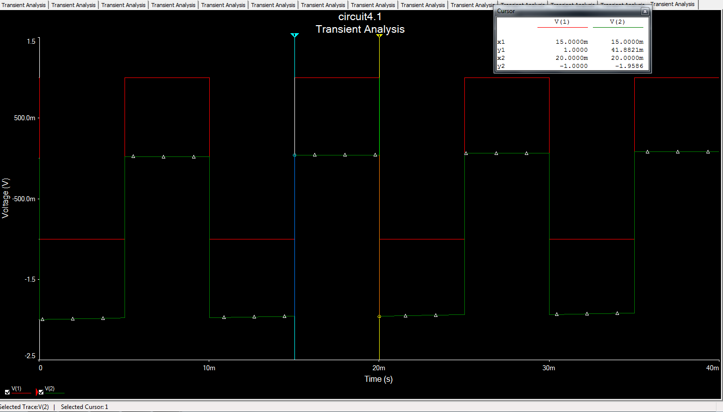

4.3 voltage doubler: clamper + peak detector :

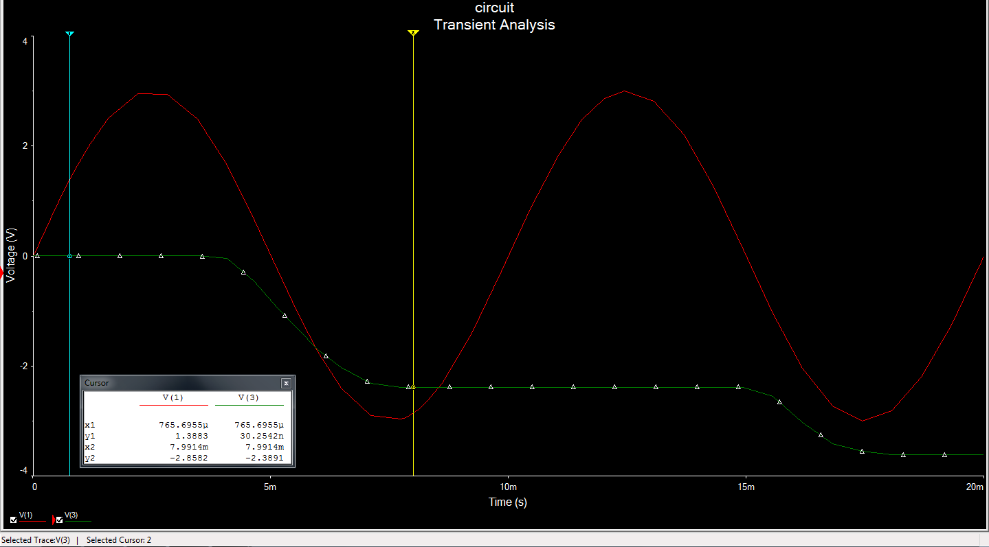

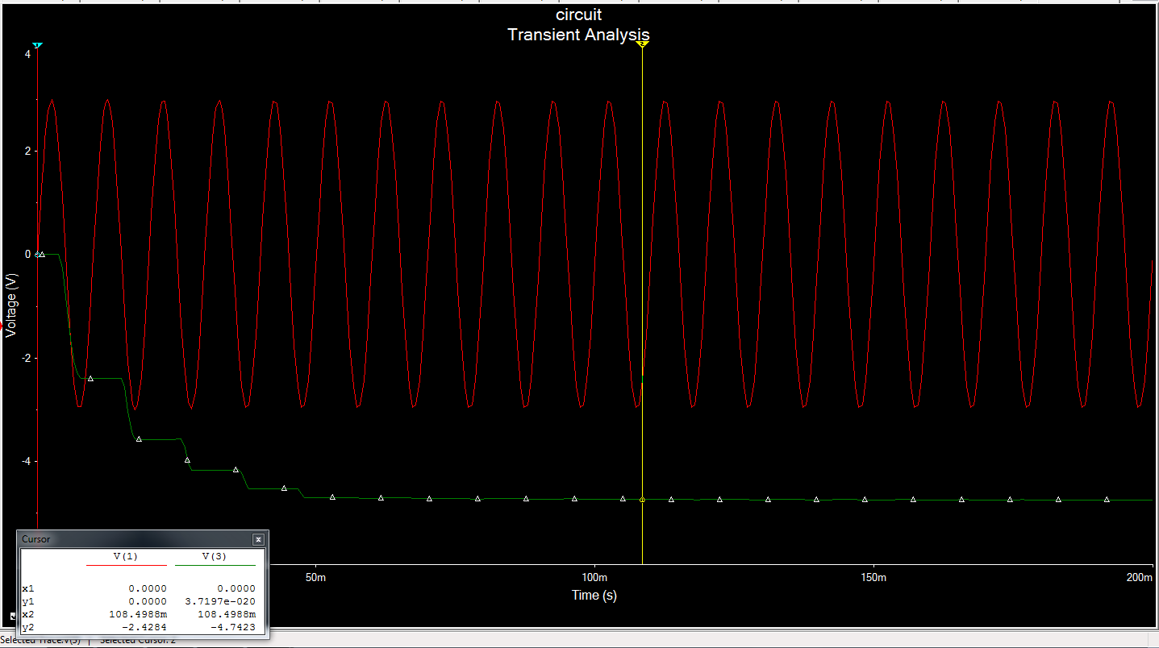

4.4 Diode Limiter circuit:

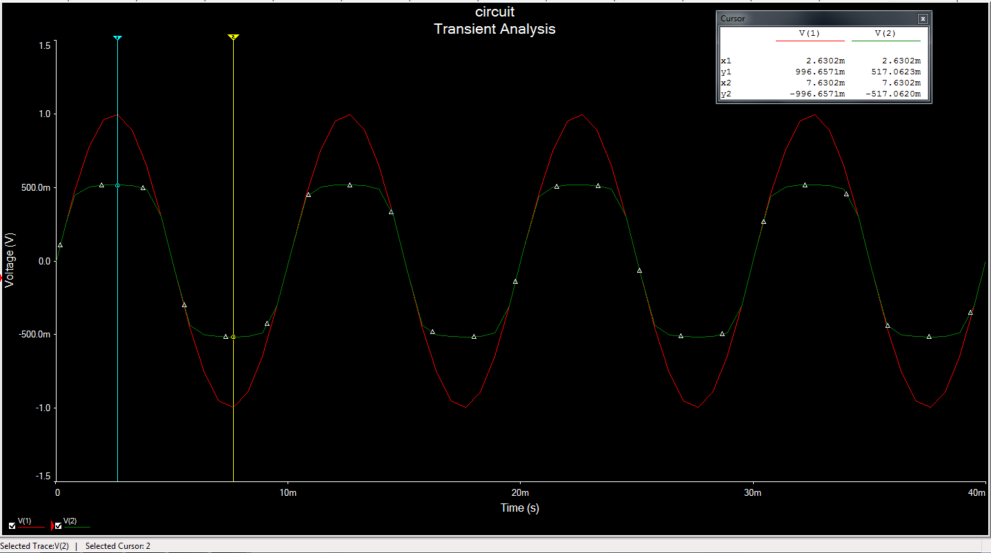

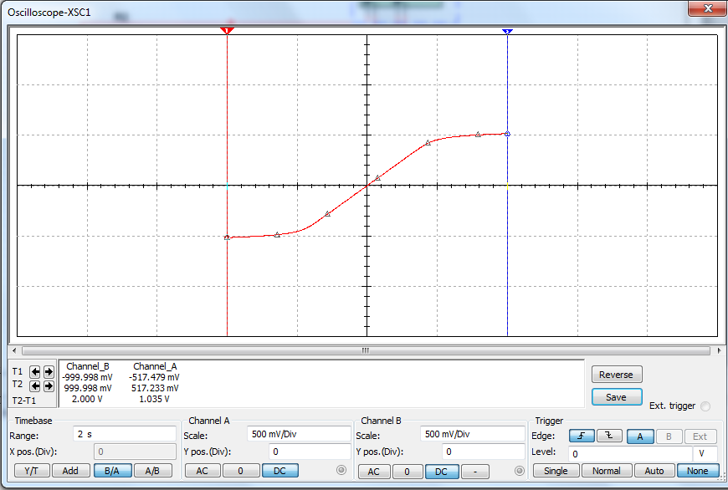

4.5:

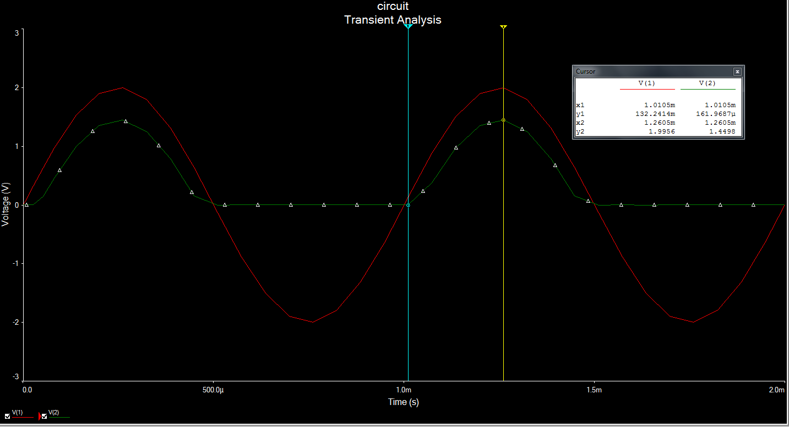

4.6:

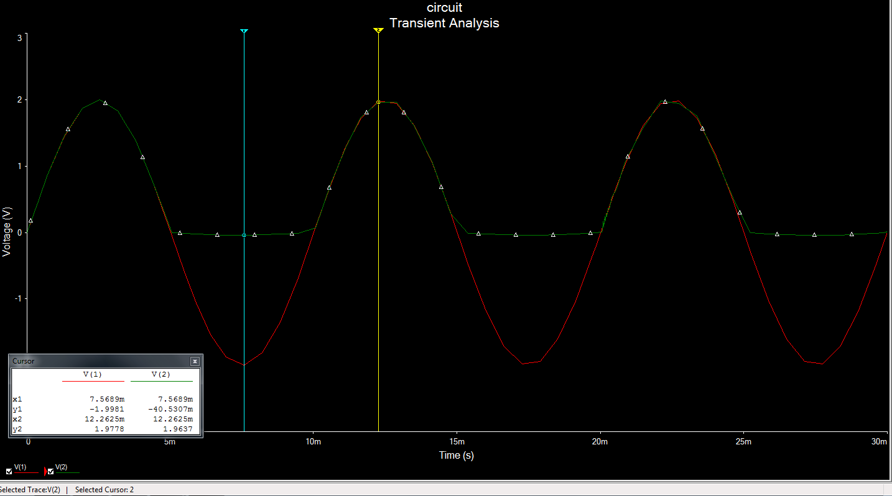

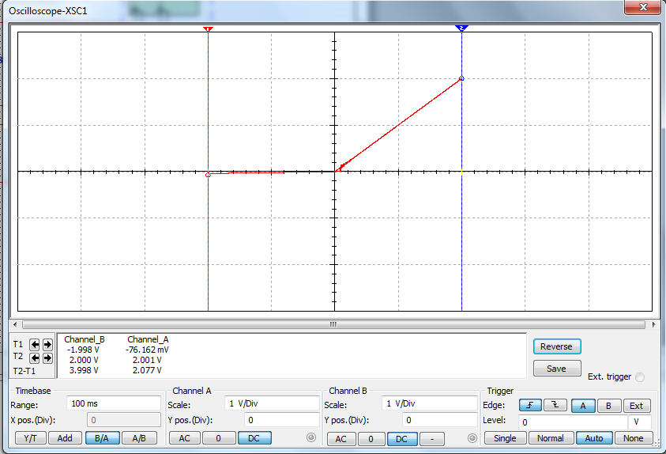

4.7

